**PROJECT- CUSTOMER CREDIT CARD SPEND ANALYSIS**

**Customer Data**

* **Columns**: num, customer_id, age, city, card_type, credit_limit, company, job_segment
* Represents customer demographic and card information.

**Repayment Data**

* **Columns**: sl_no, customer_id, date, amount
* Contains repayment transactions by customers.

**Spend Data**

* **Columns**: sl_no, customer_id, date, product_type, amount
* Tracks spending transactions across various categories.

**1. Database Creation**

First, we need to create a database to store the tables.

**SQL Command**:

CREATE DATABASE credit_card_analysis;

**2. Table Creation**

Define the schema for the Customer, Repayment, and Spending tables based on the CSV files.

**Table 1: Customer**

CREATE TABLE Customer (

num SERIAL PRIMARY KEY,

customer_id VARCHAR(10) UNIQUE NOT NULL,

age INT NOT NULL,

city VARCHAR(50) NOT NULL,

card_type VARCHAR(20) NOT NULL,

credit_limit NUMERIC(15, 2) NOT NULL,

company VARCHAR(50),

job_segment VARCHAR(50)

);

**Table 2: Repayment**

CREATE TABLE Repayment (

sl_no SERIAL PRIMARY KEY,

customer_id VARCHAR(10) REFERENCES Customer(customer_id) ON DELETE CASCADE,

date DATE NOT NULL,

amount NUMERIC(15, 2) NOT NULL

);

**Table 3: Spend**

CREATE TABLE Spend (

sl_no SERIAL PRIMARY KEY,

customer_id VARCHAR(10) REFERENCES Customer(customer_id) ON DELETE CASCADE,

date DATE NOT NULL,

product_type VARCHAR(50) NOT NULL,

amount NUMERIC(15, 2) NOT NULL

);

3. **Data Import:** right click on customer table select option import/export then select the file/path then click ok

**QUESTIONS – SQL**

* 1. **What is the average credit limit?**

SELECT AVG(credit_limit) AS average_credit_limit FROM Customer;

**Output:**

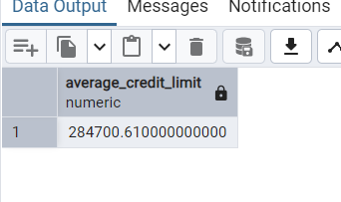

* 1. **Which type of credit card is most commonly held by customers?**

SELECT card_type, COUNT(*) AS count

FROM Customer

GROUP BY card_type

ORDER BY count DESC

LIMIT 1;

**Output:**

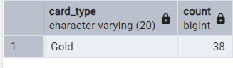

* 1. **What is the average age of credit card holders?**

SELECT AVG(age) AS average_age FROM Customer;

**Output:**

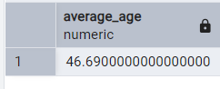

* 1. **What is the most common spending category?**

SELECT product_type, COUNT(*) AS count

FROM Spend

GROUP BY product_type

ORDER BY count DESC

LIMIT 1;

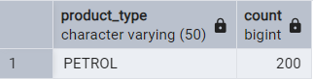**Output:**

* 1. **Show the month-wise spend across the years in descending order.**

SELECT

DATE_TRUNC('month', date) AS year_month,

SUM(amount) AS total_spend

FROM Spend

GROUP BY DATE_TRUNC('month', date)

ORDER BY total_spend DESC;

**Output:**

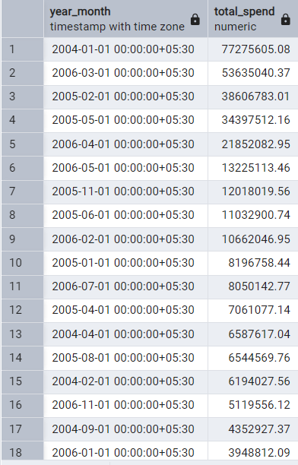

* 1. **What is the average spend per category?**

SELECT product_type, AVG(amount) AS average_spend

FROM Spend

GROUP BY product_type;

**Output**:

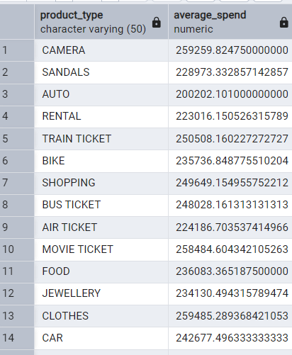

* 1. **What is the average no. of transactions per month?**

SELECT AVG(transaction_count) AS average_transactions_per_month

FROM (

SELECT COUNT(*) AS transaction_count, DATE_TRUNC('month', date) AS month

FROM Spend

GROUP BY month

) AS monthly_transactions;

**Output:**

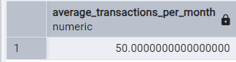

* 1. **List the top 5 cities with the highest amount spent along with their no. of transactions.**

SELECT c.city, SUM(s.amount) AS total_spend, COUNT(s.sl_no) AS transaction_count

FROM Spend s

JOIN Customer c ON s.customer_id = c.customer_id

GROUP BY c.city

ORDER BY total_spend DESC

LIMIT 5;

**Output:**

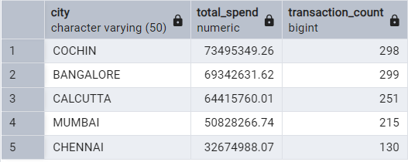

* 1. **List the card types and the amount spent with them over the years.**

SELECT c.card_type, DATE_PART('year', s.date) AS year, SUM(s.amount) AS total_spend

FROM Spend s

JOIN Customer c ON s.customer_id = c.customer_id

GROUP BY c.card_type, year

ORDER BY year, total_spend DESC;

**Output:**

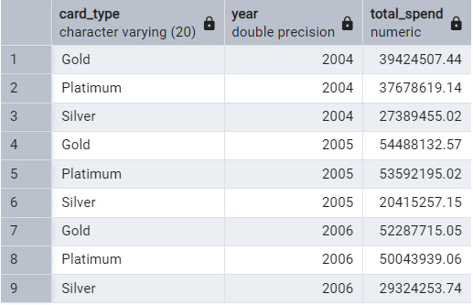

* 1. **Which is the most commonly used credit card type?**

SELECT card_type, COUNT(*) AS usage_count

FROM Customer

GROUP BY card_type

ORDER BY usage_count DESC

LIMIT 1;

**Output:**

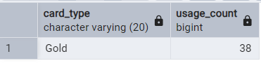

* 1. **What is the average no. of days a customer pays off their credit card bill?**
  2. **What is the rate of late-paying customers, assume the no. of days to pay off the bill is 30 days.**

SELECT

(COUNT(*) / (SELECT COUNT(*) FROM Customer)) * 100 AS LatePaymentRate

FROM (

SELECT DISTINCT customer_id

FROM repayment

WHERE (date - INTERVAL '30 days') > (SELECT MIN(date) FROM repayment WHERE customer_id = repayment.customer_id)

) AS LatePayers;

**Output:**

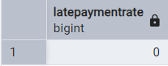

**13. Show the customer base city-wise in descending order.**

SELECT City, COUNT(*) AS CustomerCount

FROM Customer

GROUP BY City

ORDER BY CustomerCount DESC;

**Output:**

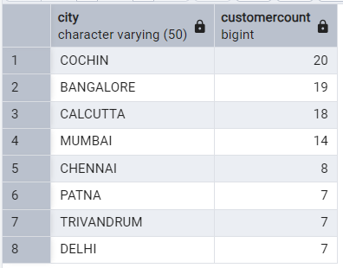

* 1. **What is the spending range of each customer?**

SELECT

customer_id,

MIN(amount) AS MinSpend,

MAX(amount) AS MaxSpend

FROM repayment

GROUP BY customer_id;

**Output:**

